**Report 1. Data Description**

**Group Members:** Rhea Rakheja, Priyanka Kishore, Michael Strobel, Jiadong Li, Richard Liang, and Olivia Majedi

**Name of project:** Temperatures in Mount Ginini, Australia

**Description**:

This data set is a subset of data from Kaggle compiled by Joe Young titled ‘Rain in Australia.’ The original source of the data is the Australian Bureau of Meteorology. We hope that this data set and analysis helps us build a better understanding of the current global warming trends.

To make the data easier to manage and to keep the correlations more consistent, we chose to focus on one location, Mount Ginini, and limit our data to the summer months. We chose this specific location because of its highly correlated maximum and minimum daily temperature, which we hope will limit the variance in our analysis.

~~Our subset of the population (N=748) contains measurements of the minimum and maximum temperature during the summer months in Mount Ginini, Australia over the years 2008-2017. The mean of the maximum temperature is 19.11 degrees Celsius, and the mean of the minimum temperature is 8.70 degrees Celsius. The correlation between minimum and maximum temperatures in 0.71, meaning 71% of the variation in the maximum temperature can be attributed to the variation in minimum temperature, and vice versa.~~

**Research question:** What is the average maximum temperature during the summer?

**Variable of interest:** Maximum and minimum temperature

**Need to be estimated:** Maximum and minimum temperatures of samples

**Population parameters** (all measurements in degrees Celsius):

|  |  |  |
| --- | --- | --- |
|  | Maximum Temperature | Minimum Temperature |
| µ | 19.108 | 8.698 |
| σ2 | 21.775 | 16.664 |
| τ | 14254.7 | 6488.9 |

**Histograms**:

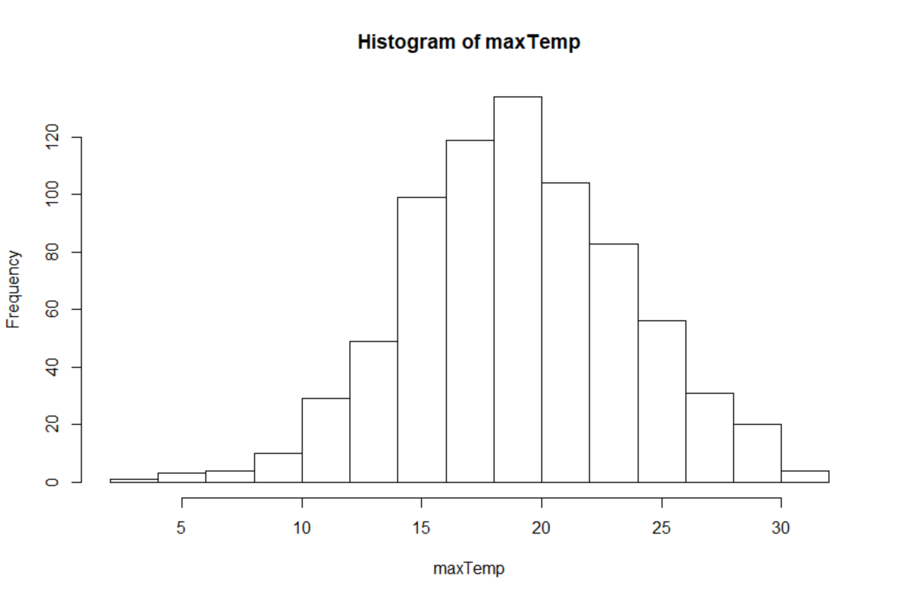

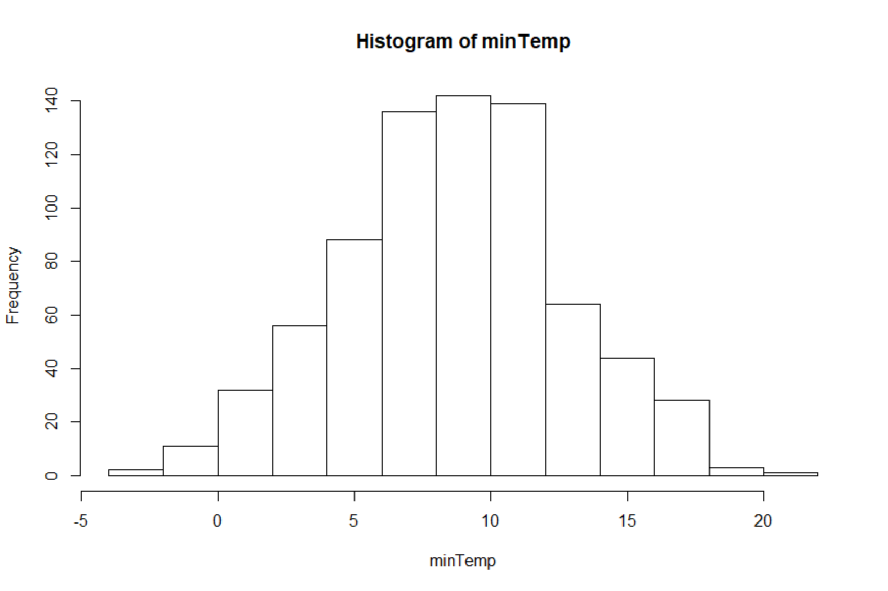

The distribution of the maximum temperatures looks fairly normally distribute, but it does have a slight left skew caused by some smaller outliers. The mean is centered around 19.11 degrees Celsius and the standard deviation is 4.66. ~~The distribution of the minimum temperatures also look normally distributed with a mean of 8.70 and a standard deviation of 4.08. Both populations lack extreme outliers.~~

Code and output:

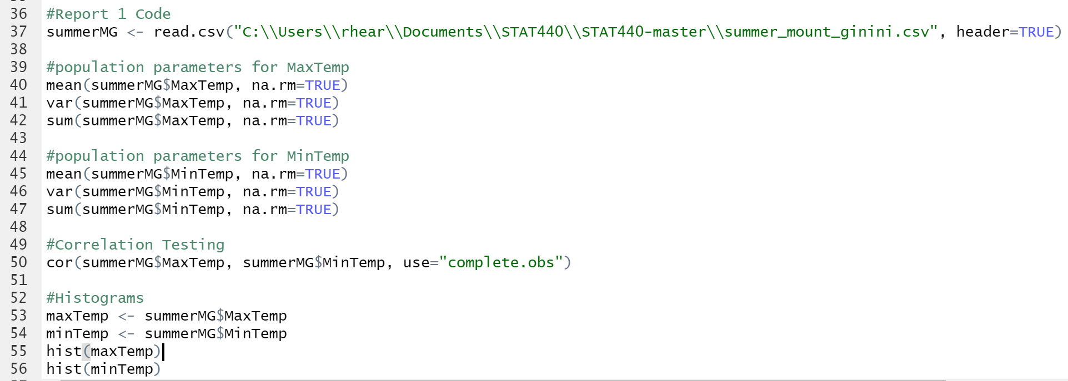

#Report 1 Code

> summerMG <- read.csv("C:\\Users\\rhear\\Documents\\STAT440\\STAT440-master\\summer_mount_ginini.csv", header=TRUE)

>

> #population parameters for MaxTemp

> mean(summerMG$MaxTemp, na.rm=TRUE)

[1] 19.10818

> var(summerMG$MaxTemp, na.rm=TRUE)

[1] 21.77468

> sum(summerMG$MaxTemp, na.rm=TRUE)

[1] 14254.7

>

~~> #population parameters for MinTemp~~

~~> mean(summerMG$MinTemp, na.rm=TRUE)~~

~~[1] 8.698257~~

~~> var(summerMG$MinTemp, na.rm=TRUE)~~

~~[1] 16.66358~~

~~> sum(summerMG$MinTemp, na.rm=TRUE)~~

~~[1] 6488.9~~

~~>~~

~~> #Correlation Testing~~

~~> cor(summerMG$MaxTemp, summerMG$MinTemp, use="complete.obs")~~

~~[1] 0.7094098~~